Title

Deliverable: title

Author: Version: 1.0 Quality review:
Date: 07 August, 2017

Grant Agreement number: 727073 Starting Date: 01/04/2017 Duration: 24 months

Coordinator: Dr. Georg Licht, ZEW

Email: licht@zew.de

www.h2020frame.eu
This project has received funding from the European Union's Horizon 2020 research and innovation programme under the grant
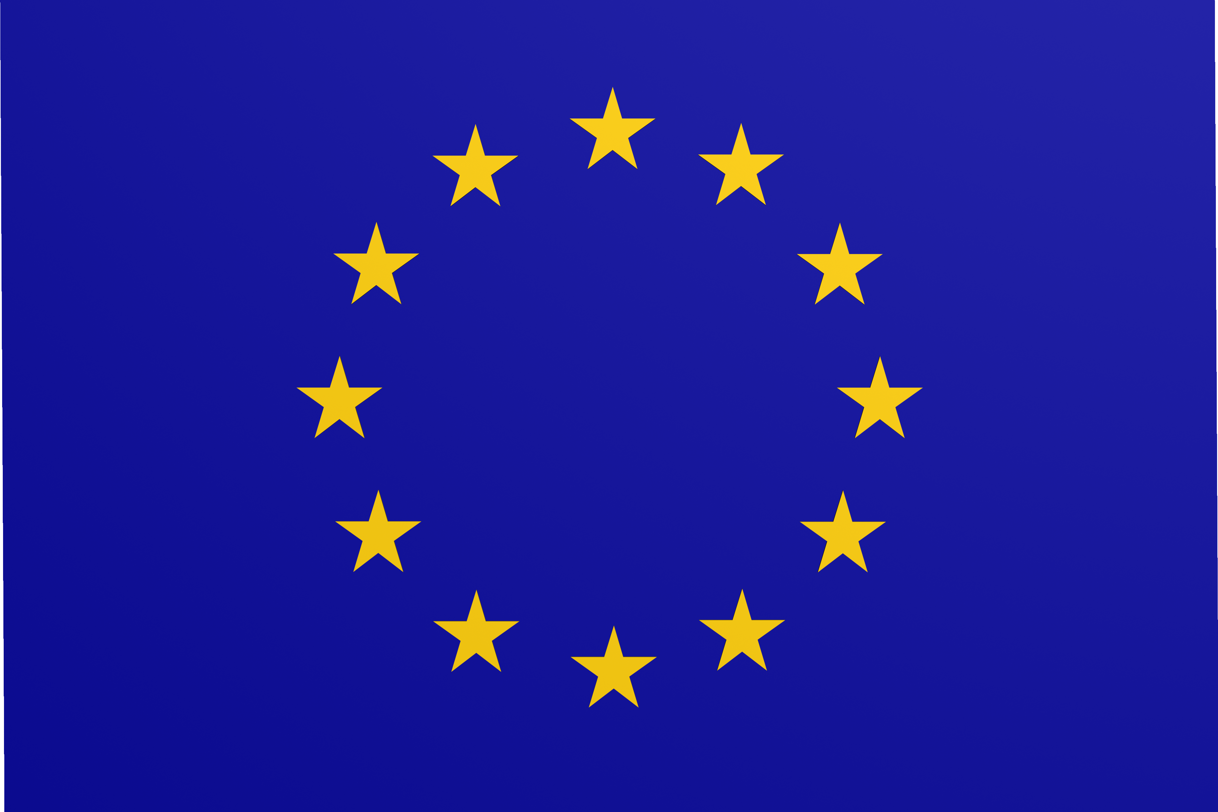agreement No 727073

Contents
- Introduction 2
- Data sources and related rights 2
  - Replication of results: R&D parameters 2
  - Replication of results: adoption parameters 2
- Diffusing results and practices 2
- Concluding remarks 3

Introduction
The current report presents the main infrastructure which will be developed to allow the general use of the FRAME data and scripts. In line with the ongoing debate about Open Science, the research data depository aims at making possible for third parties to access, to mine, to exploit, to reproduce, and to disseminate results without additional costs. The main results and description of the variables will be disclosed in scientific peer-reviewed articles.

Data sources and related rights
Different types of data are crossed within the Work Package 6 for the estimation of the calibrated parameters used across the work packages. Four main different databases are involved which combine several sources of information...

Replication of results: R&D parameters
To facilitate the uptake of the project, FRAME will ensure the maximum of transparency in order to replicate results. To do so, efforts will be made to ensure the public disclosure of the scripts (see next section) and the access to the datasets involved, unless specific confidentiality requirements prevent it. In this regard, most of the datasets should be accessible for replication studies and training purposes. The first set of parameters estimated relates to R&D parameters. The latter are estimated based on national statistical offices, EUROSTAT, Patstat data. The matching procedure used on Patstat to delineate sectors and countries will be made available for replication...

Replication of results: adoption parameters
The estimation of the adoption parameters relies on various existing datasets: the CHAT dataset, the Government Budget Appropriation Of Research and Development (GBAORD) data, and the result of a matching procedure between German CIS data and the Fraunhofer data.

Diffusing results and practices
In order to allow the use of the models by third parties, to exploit new insights, or to extend the models, the scripts involved in each Work Package will be available on the website. If necessary, a depository will be created on GITHUB and added on the website. The software programs used to code the different models are widely spread among the scientific community (Stata, R, Matlab, Dynare, GAUSS) and provides the maximum of transparency. Doing so will pave the ground for reproducibility of the findings and potential extensions. One exception will be the algorithm (“search engine”) developed in ZEW in order to match patent data with large firms databases.
Different types of workshops, summer schools, and training seminars will be created to diffuse the use of the model. The first workshop to introduce the features of the model is scheduled for the 13th of September. The meeting will take place in Brussels at the initiative of the DG RTD unit and combined with the MONROE project. Regarding the publication of the results, we will try to ensure that the maximum of publications will follow the “gold open access” rule by sending them to open access journals. In the case that journals do not follow this logic, we will apply a “green open access”: in line with the requirements of the Horizon 2020, researchers

will ensure that the related articles will be openly available and free of costs. Working Papers depositories of each institution involved in the FRAME project will be also be considered to accelerate the speed of diffusion of the findings (“green open access”). The links towards each working paper depository will be made through the website after receiving the approval of the Commission.

Concluding remarks
The information generated before the beginning of the project will remain the property of the partners...

